TMT/BENUGOPAL/S0356/2025 03-07-2025
To,

Benudhar

Palasuni, Bhubaneshwar

Mobile: +91 90907 39198

Dear Sirs,

Sub: - Supply of Three Roller Plate bending machine with Pre-Pinching.

We thank you for your enquiry regarding Plate Bending machine for MS plate width 2500 thickness of 25 mm. We are glad to inform you that we would be in a position to do the required equipment with the following specifications and description of the machine along with our terms and conditions.

S No | Description of the unit | Offer
1. | Plate bending machine for 2500x25 mm with 25 HP main drive 10 HP-2 load drives along with complete electricals. | Rs 32,00,000/- (Rupees Thirty two Lakhs only)

Main drive : 25 HP
Screw drive: 10 HP - 2 nos
Door opening : 5 HP
Oil pump :.5 HP

Specifications of the equipment :

1) Maximum width of Rolling : 2550 MM

2) Maximum thickness of Rolling : 25 MM

2a) pre pinching capacity : upto 20 mm for MS
Upto 16 mm for SS

3) Top Roll diameter : 360 MM

4) Bottom Roller Diameter : 345 MM

5) Minimum Rolling Diameter : 760 MM

6) Rolling speed : 3.3 rpm.

7) Maximum yield limit of the plate : 245 Mpa.

8) Total power : 50.5 HP

GENERAL TERMS & CONDITIONS:

- Price quoted per unit ex-work. Hyderabad.
- Following charges are additional to your account.
- Freight Charge : As actual to be borne by you.
- Excise : Extra As Applicable
- Sales Tax : Extra as applicable
- Packing charge : As actual to be borne by you.
- Insurance : As actual to be borne by you.
- Payment : 50% advance along with order balance before despatch
- Delivery : delivery within 3 months.
- Validity : One month from the date of submission.
- Inspection : Inspection at our works prior to dispatch.
- Warranty : The machine is warranted for a period of 12 months from the date of dispatch against any manufacturing defects/ faulty material or bad workmanship of any part or component but not against any kind of abnormal or improper use of machine. Defective part or component will be replaced or repaired free of cost. Electrical components are outside the scope of this warranty.
- Commissioning : Erection & commissioning done by you, but required technical support & guidance provide by us at additional cost.
NOTE:
- Oil is not in our scope of supply.
- Raw material for trial is to be arranged by you at your cost.

We are sure you will find our offer in line with your requirements. Should you require any further clarification please contact 9246221106/9849207176 email: srktalam@gmail.com

Thanking you and assuring you of our best services.

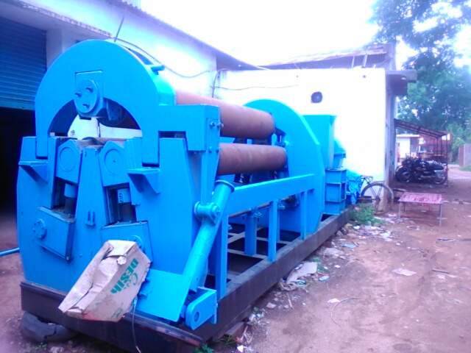

For TECHNO MACHINE TOOLS

( T. SIVARAMAKRISHNA) .

